**Homepage**



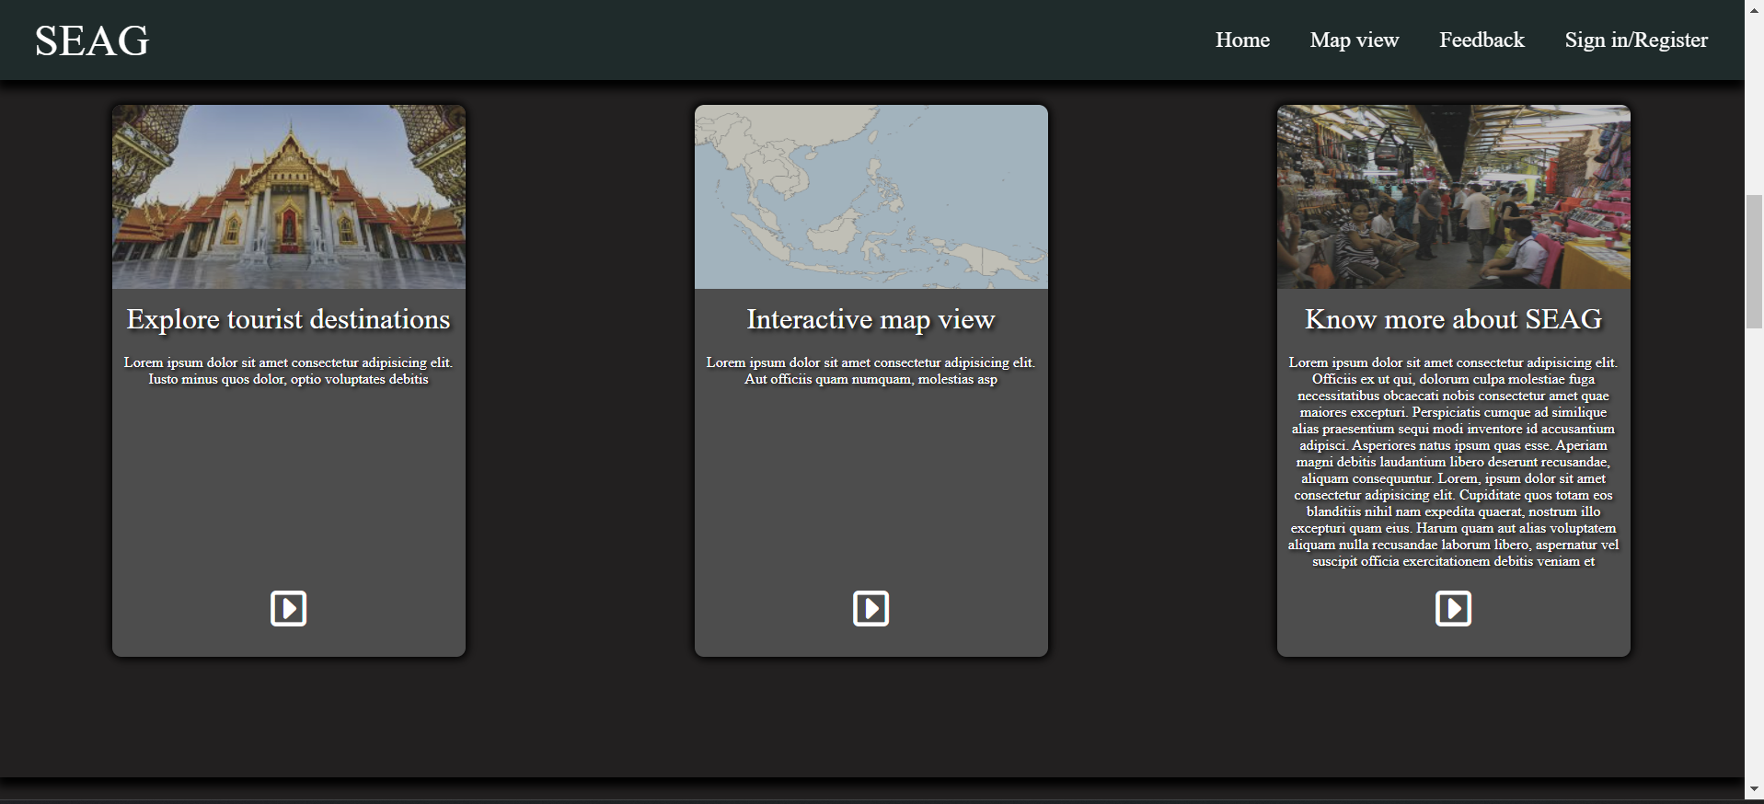

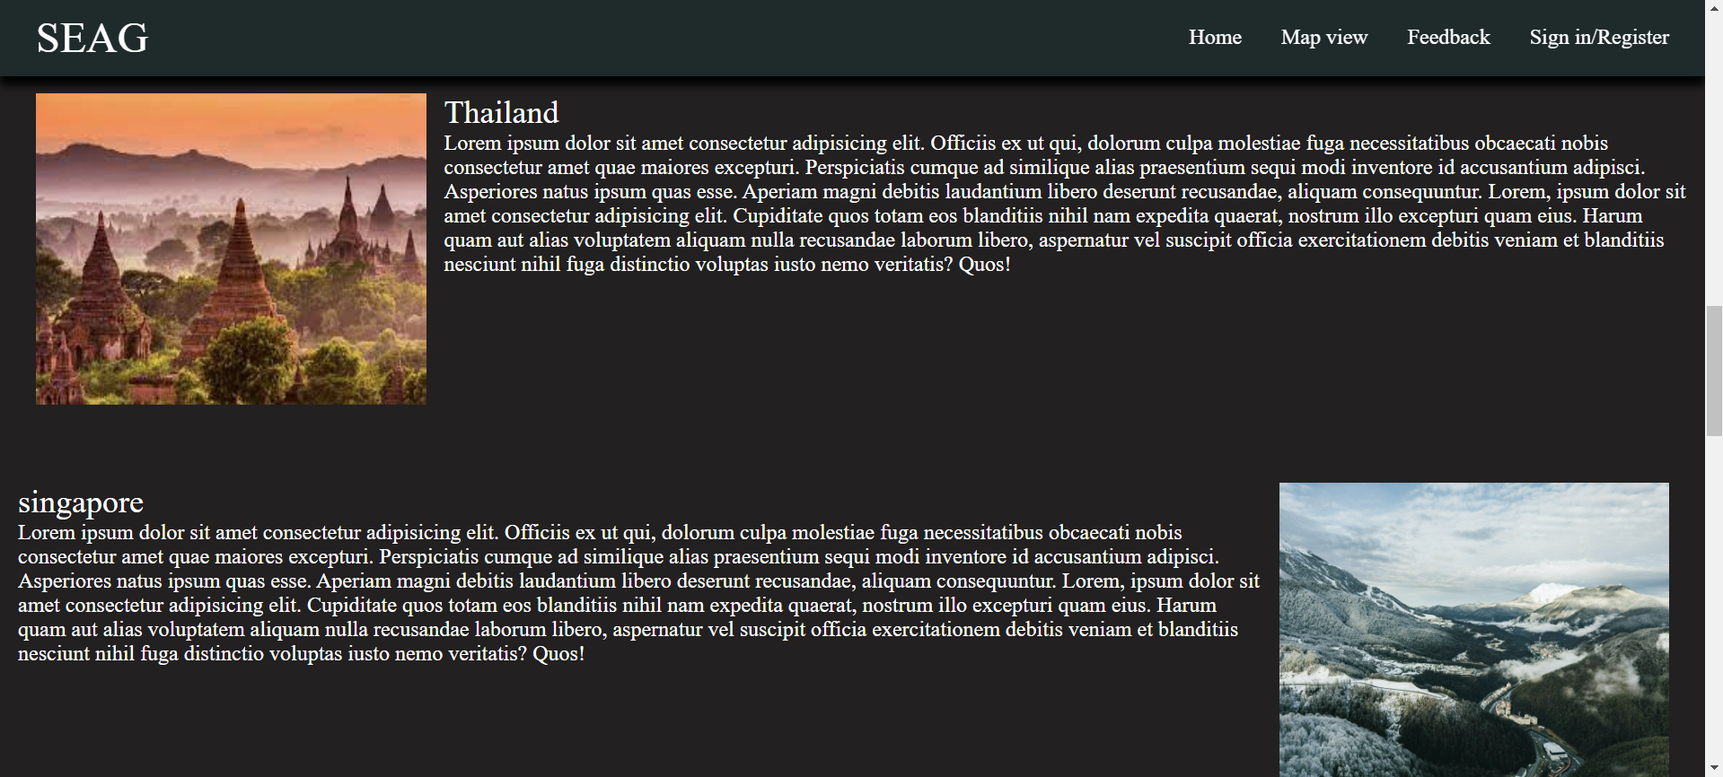

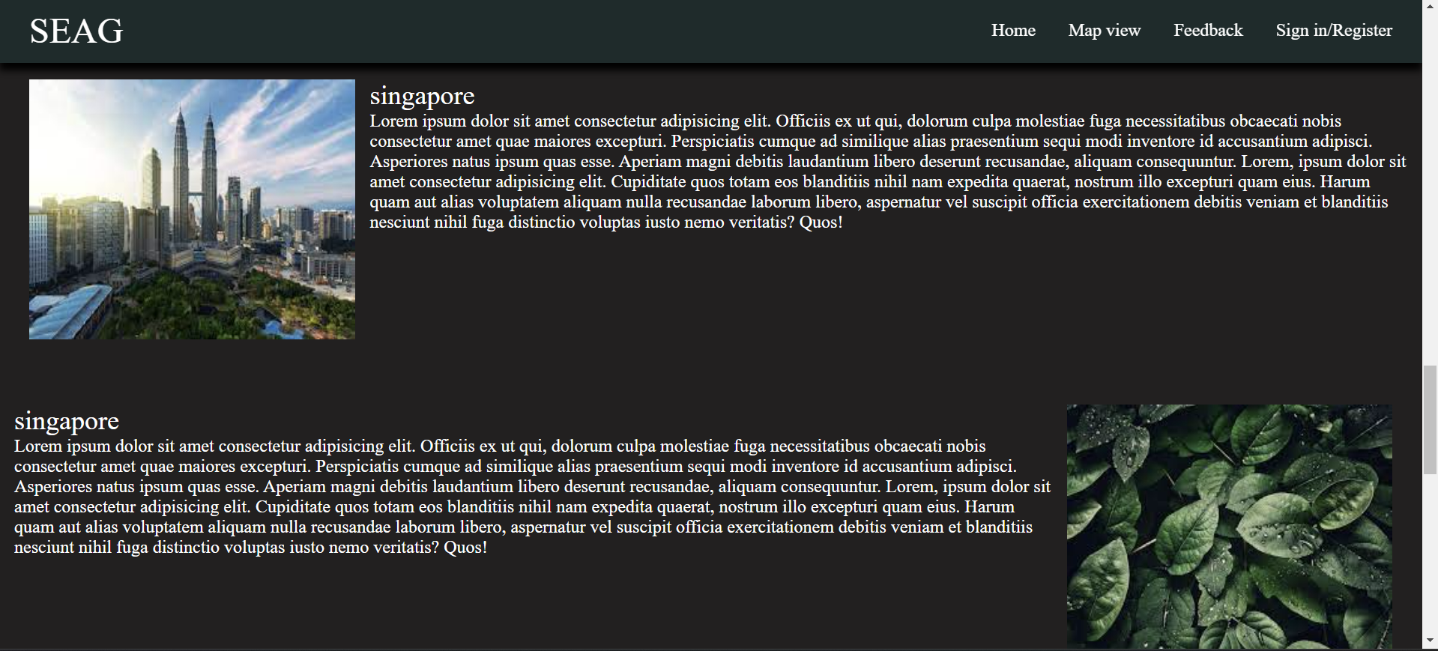

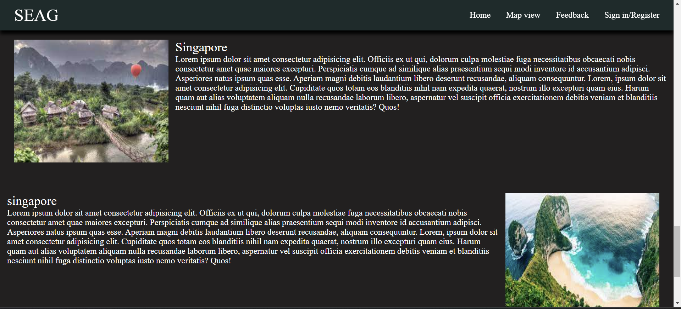

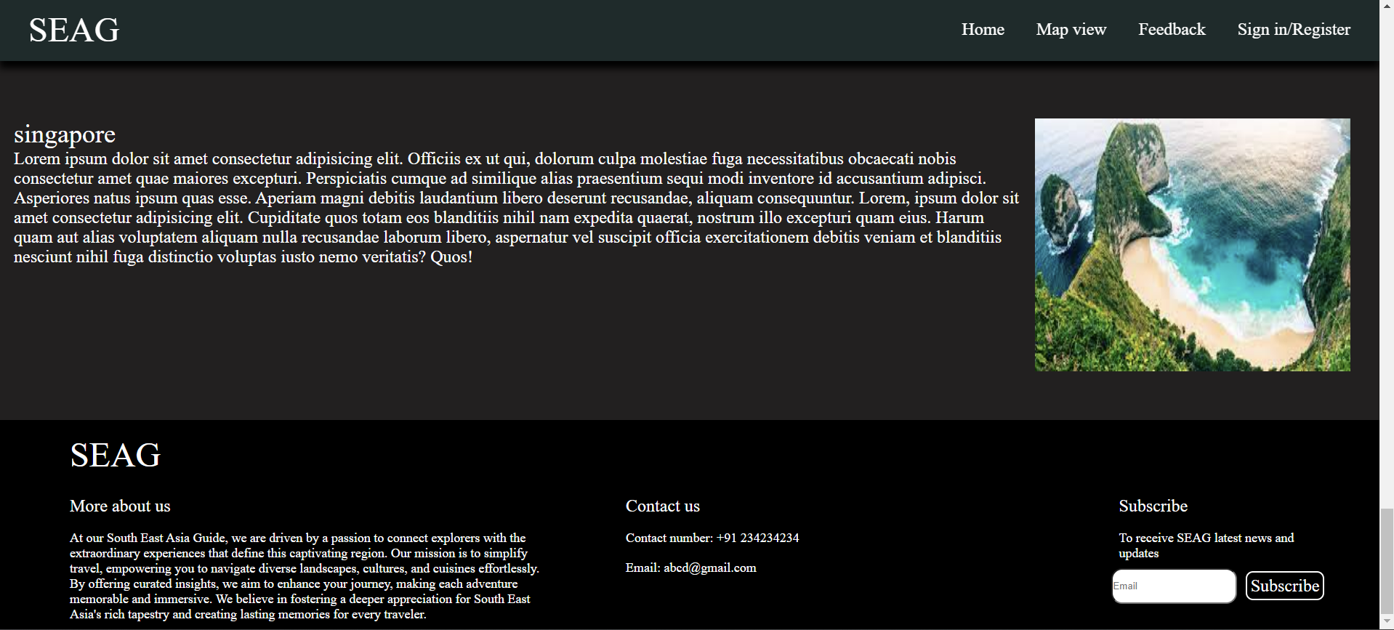

**Map view**

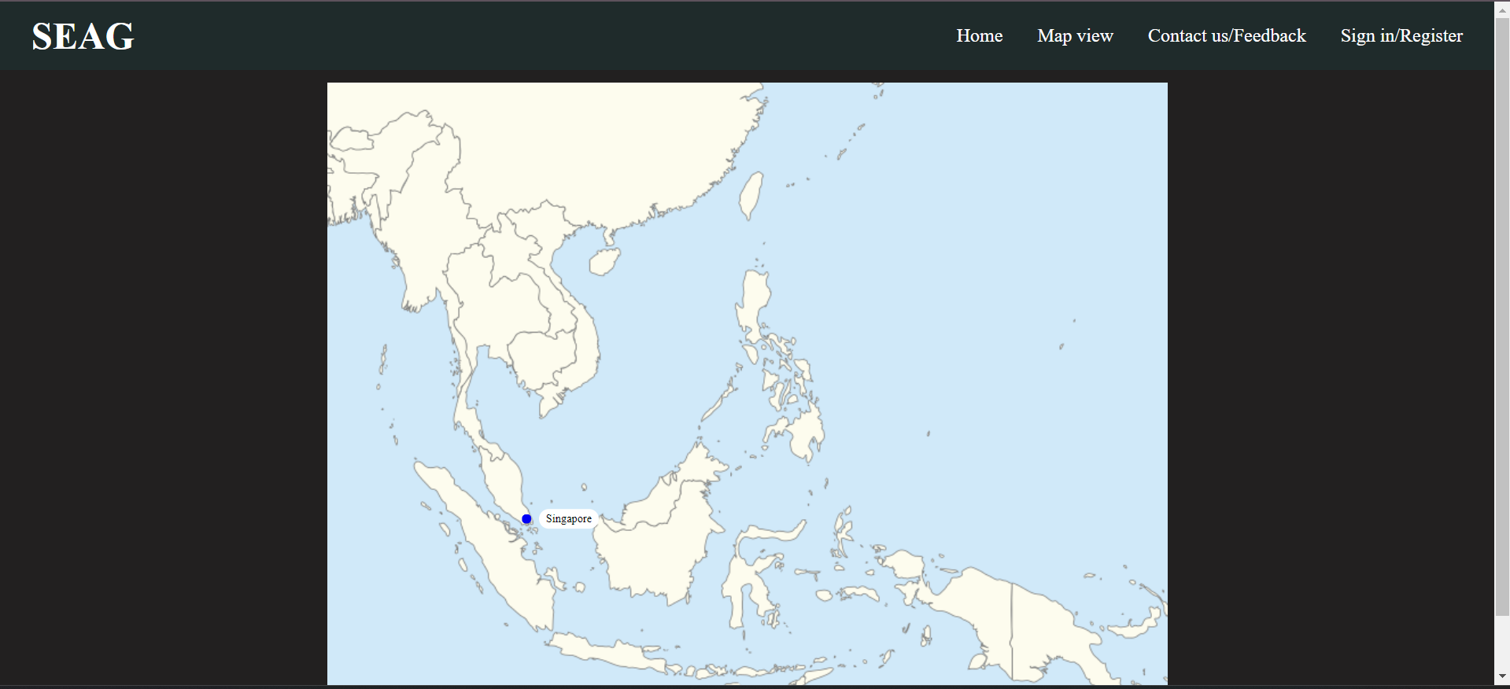

**Feedback page**

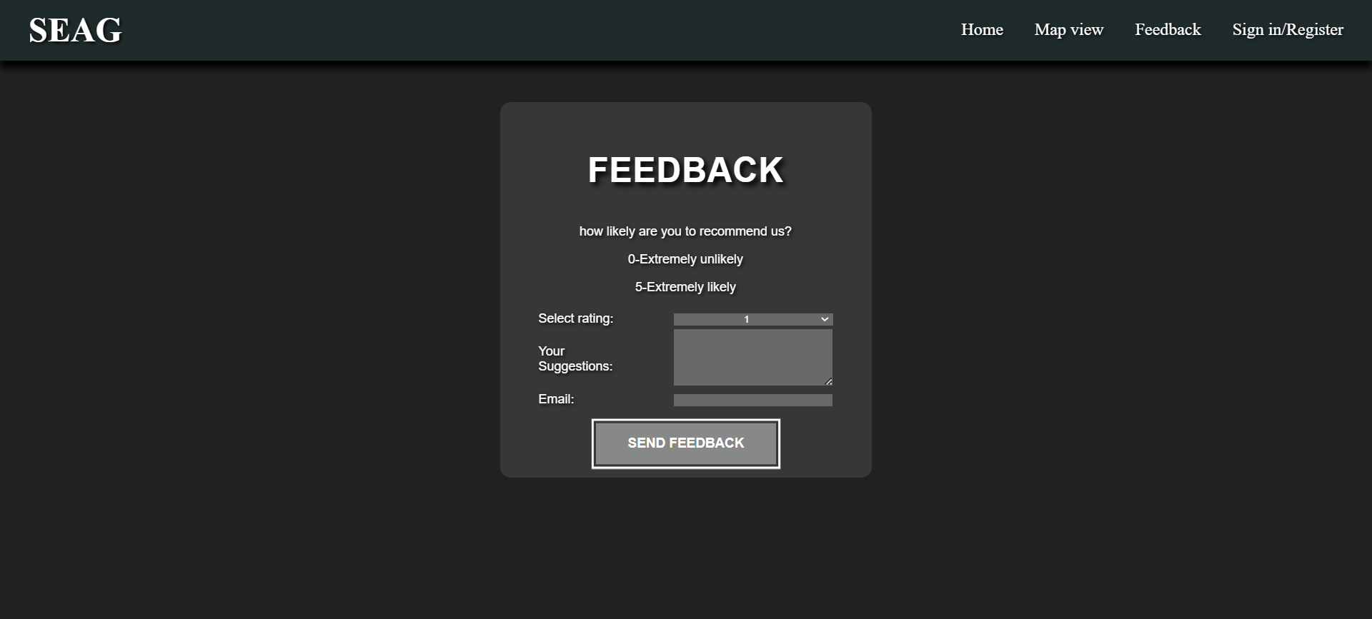

**Register/sign in page**

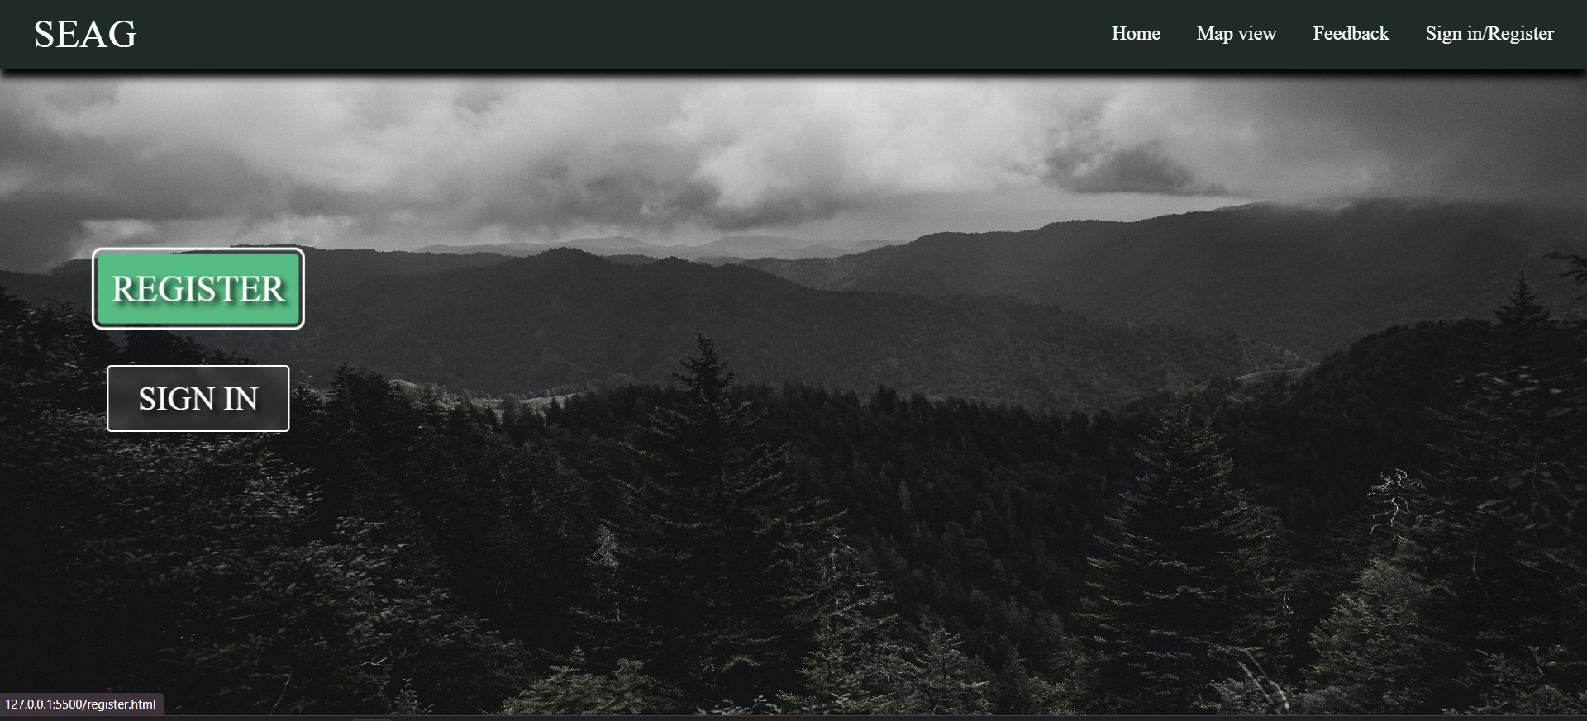

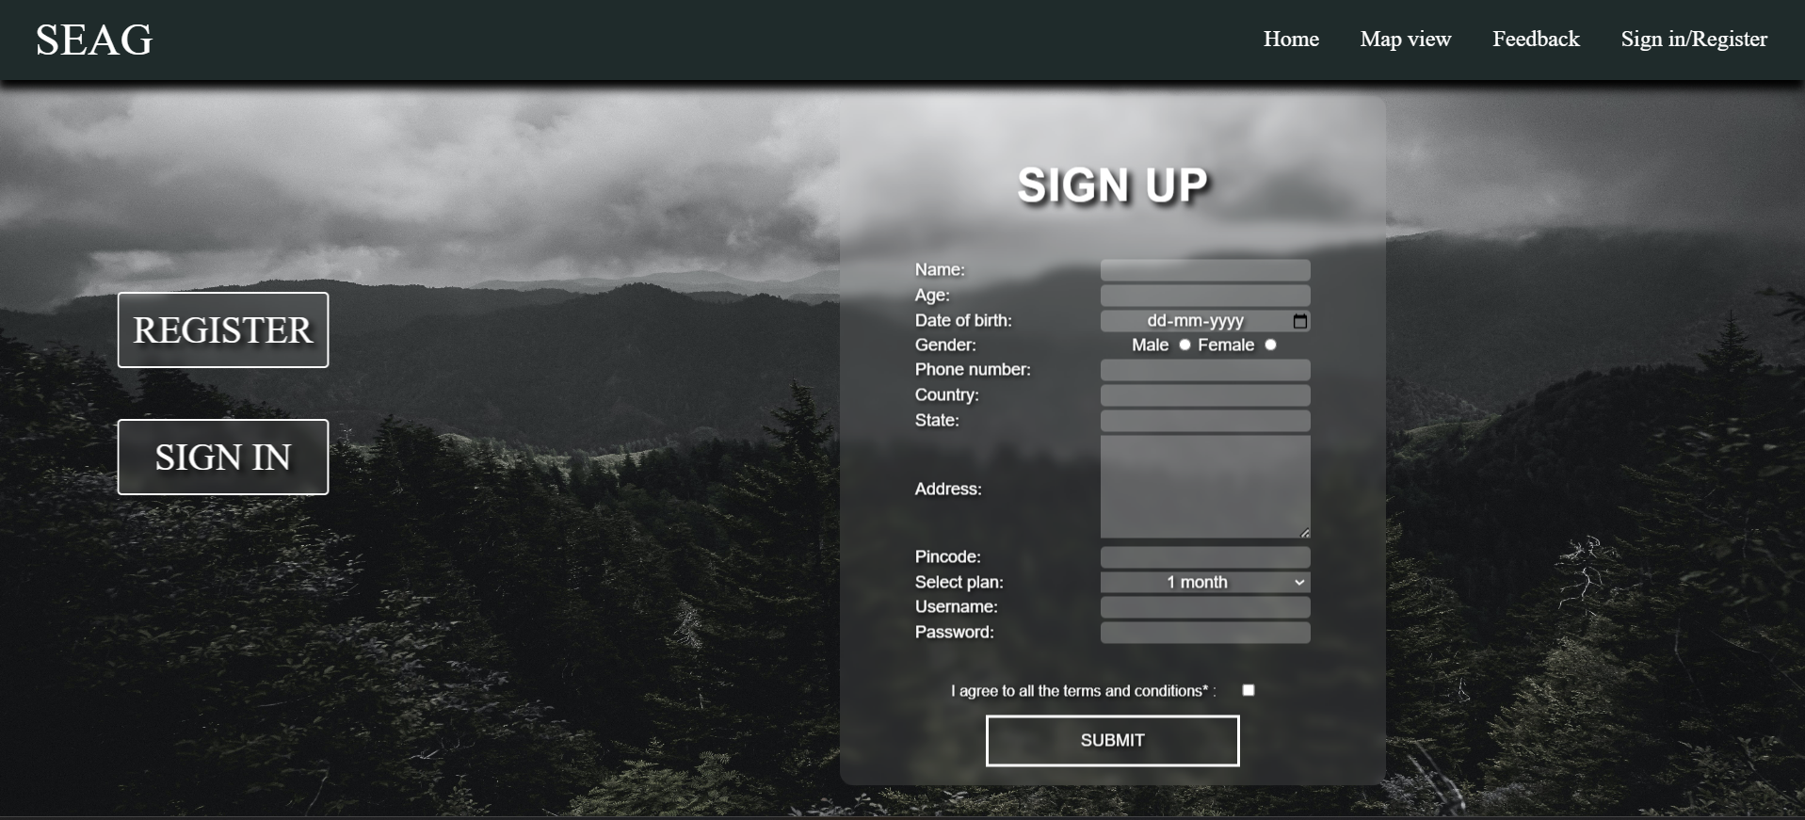

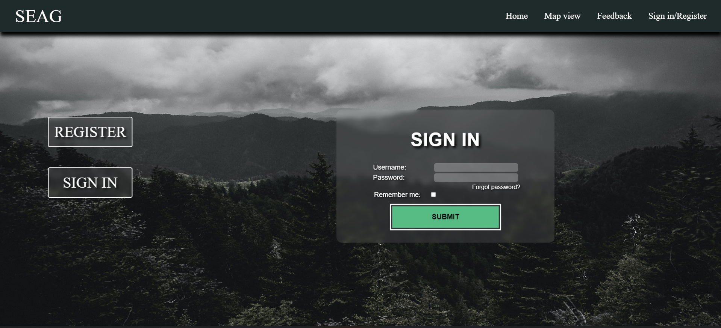

**Miniproject.html**

<!DOCTYPE html>

<html lang="en">

<head>

<link rel="stylesheet" href="https://cdnjs.cloudflare.com/ajax/libs/font-awesome/6.5.1/css/all.min.css"

integrity="sha512-DTOQO9RWCH3ppGqcWaEA1BIZOC6xxalwEsw9c2QQeAIftl+Vegovlnee1c9QX4TctnWMn13TZye+giMm8e2LwA=="

crossorigin="anonymous" referrerpolicy="no-referrer" />

<meta charset="UTF-8">

<meta name="viewport" content="width=device-width, initial-scale=1.0">

<title>Mini project</title>

<link rel="stylesheet" href="index.css">

<link rel="preconnect" href="https://fonts.googleapis.com">

<link rel="preconnect" href="https://fonts.gstatic.com" crossorigin>

<!-- <link href="https://fonts.googleapis.com/css2?family=Cinzel+Decorative:wght@400;700;900&family=Quicksand:wght@300..700&display=swap" rel="stylesheet"> -->

<body>

<div class="navbar">

<a href="mini_project.html"><h1> SEAG</h1></a>

<ul class="links">

<li><a href="mini_project.html">Home</a></li>

<li><a href="map.html">Map view</a></li>

<li><a href="contact.html">Feedback</a></li>

<li><a href="ifram.html">Sign in/Register</a></li>

</ul>

</div>

<!-- <img src="static\map2.jpg" width="100%" alt="countries picture"> -->

<!-- <br> -->

<div class="carousal">

<div class="headtext">

<h1>WELCOME TO SEAG</h1>

<p>DISCOVER THE HIDDEN GEMS OF OUR WORLD</p>

</div>

<div class="explore">

<a href="#cc">EXPLORE &nbsp;<i class="fas fa-angle-double-right"></i></a>

</div>

</div>

<div class="cardcontainer" id="cc">

<div class="card 1">

<div class="cardimg">

<img src="static\thailand.jpeg" alt="">

</div>

<div class="cardtext">

<h2>

Explore tourist destinations

</h2>

<p>Lorem ipsum dolor sit amet consectetur adipisicing elit. Iusto minus quos dolor, optio voluptates debitis </p>

</div>

<div class="cardbutton">

<a href=""><i class="far fa-caret-square-right"></i></a>

</div>

</div>

<div class="card 2">

<div class="cardimg">

<img

src="static\Southeast_Asia_location_map.svg.png" alt="">

</div>

<div class="cardtext">

<h2>Interactive map view</h2>

<p>Lorem ipsum dolor sit amet consectetur adipisicing elit. Aut officiis quam numquam, molestias asp</p>

</div>

<div class="cardbutton">

<a href="map.html"><i class="far fa-caret-square-right"></i></a>

</div>

</div>

<div class="card 3">

<div class="cardimg">

<img src="static\5066707585_97e9831a48_o_20180522174946.jpg" alt="">

</div>

<div class="cardtext">

<h2>Know more about SEAG</h2>

<p>Lorem ipsum dolor sit amet consectetur adipisicing elit. Officiis ex ut qui, dolorum culpa molestiae fuga

necessitatibus obcaecati nobis consectetur amet quae maiores excepturi. Perspiciatis cumque ad similique alias

praesentium sequi modi inventore id accusantium adipisci. Asperiores natus ipsum quas esse. Aperiam magni debitis

laudantium libero deserunt recusandae, aliquam consequuntur. Lorem, ipsum dolor sit amet consectetur adipisicing elit. Cupiditate quos totam eos blanditiis nihil nam expedita quaerat, nostrum illo excepturi quam eius. Harum quam aut alias voluptatem aliquam nulla recusandae laborum libero, aspernatur vel suscipit officia exercitationem debitis veniam et blanditiis nesciunt nihil fuga distinctio voluptas iusto nemo veritatis? Quos!</p>

</div>

<div class="cardbutton">

<a href=""><i style="bottom: 10px;" class="far fa-caret-square-right"></i></a>

</div>

</div>

</div>

<div class=" contentline">

<div class="content ">

<img src="static\myanmar.jpeg" alt="">

<div class="contenttxt">

<h2>Thailand

</h2>

<p>Lorem ipsum dolor sit amet consectetur adipisicing elit. Officiis ex ut qui, dolorum culpa molestiae fuga

necessitatibus obcaecati nobis consectetur amet quae maiores excepturi. Perspiciatis cumque ad similique alias

praesentium sequi modi inventore id accusantium adipisci. Asperiores natus ipsum quas esse. Aperiam magni debitis

laudantium libero deserunt recusandae, aliquam consequuntur. Lorem, ipsum dolor sit amet consectetur adipisicing elit.

Cupiditate quos totam eos blanditiis nihil nam expedita quaerat, nostrum illo excepturi quam eius. Harum quam aut alias

voluptatem aliquam nulla recusandae laborum libero, aspernatur vel suscipit officia exercitationem debitis veniam et

blanditiis nesciunt nihil fuga distinctio voluptas iusto nemo veritatis? Quos!</p>

</div>

</div>

<div class="contentright ">

<div class="contenttxt">

<h2>singapore</h2>

<p>Lorem ipsum dolor sit amet consectetur adipisicing elit. Officiis ex ut qui, dolorum culpa molestiae fuga

necessitatibus obcaecati nobis consectetur amet quae maiores excepturi. Perspiciatis cumque ad similique alias

praesentium sequi modi inventore id accusantium adipisci. Asperiores natus ipsum quas esse. Aperiam magni debitis

laudantium libero deserunt recusandae, aliquam consequuntur. Lorem, ipsum dolor sit amet consectetur adipisicing elit.

Cupiditate quos totam eos blanditiis nihil nam expedita quaerat, nostrum illo excepturi quam eius. Harum quam aut alias

voluptatem aliquam nulla recusandae laborum libero, aspernatur vel suscipit officia exercitationem debitis veniam et

blanditiis nesciunt nihil fuga distinctio voluptas iusto nemo veritatis? Quos!</p>

</div>

<img src="static\pexels-mike-1181768.jpg" alt="">

</div>

</div>

</div>

<div class=" contentline">

<div class="content ">

<img src="static\kuala.jpeg" alt="">

<div class="contenttxt">

<h2>singapore</h2>

<p>Lorem ipsum dolor sit amet consectetur adipisicing elit. Officiis ex ut qui, dolorum culpa molestiae fuga

necessitatibus obcaecati nobis consectetur amet quae maiores excepturi. Perspiciatis cumque ad similique alias

praesentium sequi modi inventore id accusantium adipisci. Asperiores natus ipsum quas esse. Aperiam magni debitis

laudantium libero deserunt recusandae, aliquam consequuntur. Lorem, ipsum dolor sit amet consectetur adipisicing elit.

Cupiditate quos totam eos blanditiis nihil nam expedita quaerat, nostrum illo excepturi quam eius. Harum quam aut alias

voluptatem aliquam nulla recusandae laborum libero, aspernatur vel suscipit officia exercitationem debitis veniam et

blanditiis nesciunt nihil fuga distinctio voluptas iusto nemo veritatis? Quos!</p>

</div>

</div>

<div class="contentright ">

<div class="contenttxt">

<h2>singapore</h2>

<p>Lorem ipsum dolor sit amet consectetur adipisicing elit. Officiis ex ut qui, dolorum culpa molestiae fuga

necessitatibus obcaecati nobis consectetur amet quae maiores excepturi. Perspiciatis cumque ad similique alias

praesentium sequi modi inventore id accusantium adipisci. Asperiores natus ipsum quas esse. Aperiam magni debitis

laudantium libero deserunt recusandae, aliquam consequuntur. Lorem, ipsum dolor sit amet consectetur adipisicing elit.

Cupiditate quos totam eos blanditiis nihil nam expedita quaerat, nostrum illo excepturi quam eius. Harum quam aut alias

voluptatem aliquam nulla recusandae laborum libero, aspernatur vel suscipit officia exercitationem debitis veniam et

blanditiis nesciunt nihil fuga distinctio voluptas iusto nemo veritatis? Quos!</p>

</div>

<img src="static\download (2).jpeg" alt="">

</div>

</div>

<div class=" contentline last">

<div class="content ">

<img src="static\laos.jpeg" alt="">

<div class="contenttxt">

<h2>Singapore</h2>

<p>Lorem ipsum dolor sit amet consectetur adipisicing elit. Officiis ex ut qui, dolorum culpa molestiae fuga

necessitatibus obcaecati nobis consectetur amet quae maiores excepturi. Perspiciatis cumque ad similique alias

praesentium sequi modi inventore id accusantium adipisci. Asperiores natus ipsum quas esse. Aperiam magni debitis

laudantium libero deserunt recusandae, aliquam consequuntur. Lorem, ipsum dolor sit amet consectetur adipisicing elit. Cupiditate quos totam eos blanditiis nihil nam expedita quaerat, nostrum illo excepturi quam eius. Harum quam aut alias voluptatem aliquam nulla recusandae laborum libero, aspernatur vel suscipit officia exercitationem debitis veniam et blanditiis nesciunt nihil fuga distinctio voluptas iusto nemo veritatis? Quos!</p>

</div>

</div>

<div class="contentright ">

<div class="contenttxt">

<h2>singapore</h2>

<p>Lorem ipsum dolor sit amet consectetur adipisicing elit. Officiis ex ut qui, dolorum culpa molestiae fuga

necessitatibus obcaecati nobis consectetur amet quae maiores excepturi. Perspiciatis cumque ad similique alias

praesentium sequi modi inventore id accusantium adipisci. Asperiores natus ipsum quas esse. Aperiam magni debitis

laudantium libero deserunt recusandae, aliquam consequuntur. Lorem, ipsum dolor sit amet consectetur adipisicing elit. Cupiditate quos totam eos blanditiis nihil nam expedita quaerat, nostrum illo excepturi quam eius. Harum quam aut alias voluptatem aliquam nulla recusandae laborum libero, aspernatur vel suscipit officia exercitationem debitis veniam et blanditiis nesciunt nihil fuga distinctio voluptas iusto nemo veritatis? Quos!</p>

</div>

<img src="static\loginbg.jpeg" alt="">

</div>

</div>

<footer>

<h1>SEAG</h1>

<div class="foottxt">

<div class="col col1">

<h2>More about us</h2>

<p>At our South East Asia Guide, we are driven by a passion to connect explorers with the extraordinary experiences that

define this captivating region. Our mission is to simplify travel, empowering you to navigate diverse landscapes,

cultures, and cuisines effortlessly. By offering curated insights, we aim to enhance your journey, making each adventure

memorable and immersive. We believe in fostering a deeper appreciation for South East Asia's rich tapestry and creating

lasting memories for every traveler.</p>

</div>

<div class="col col2">

<h2>Contact us</h2>

<p>Contact number: +91 234234234</p>

<p>Email: abcd@gmail.com</p>

</div>

<div class="col col3">

<h2>Subscribe </h2>

<p>To receive SEAG latest news and updates</p>

<div class="sub">

<input type="email" placeholder="Email">

<div class="explore"><a href="#">Subscribe</a></div>

</div>

</div>

</div>

</footer>

<!-- <h1>MYANMAR</h1>

<img src="static\myanmar.jpeg" width="25%" alt="">

<p><font size="5">Burma, officially known as Myanmar, is a Southeast Asian nation with a rich cultural heritage. It boasts diverse

landscapes, including lush jungles and ancient temples. Despite its natural beauty, the country has faced political

challenges and human rights issues. In recent years, it has been striving for democratic reforms and international

engagement.</font></p>

<h1>LAOS</h1>

<img src="static\laos.jpeg" width="25%" alt="">

<p><font size="5">Laos, a landlocked country in Southeast Asia, is known for its lush landscapes, Mekong River, and rich cultural

heritage. Vientiane, the capital, reflects a blend of French colonial architecture and traditional Buddhist temples.

Laos embraces a tranquil pace of life, with its friendly people, vibrant markets, and delicious cuisine.

</font>

</p>

<h1>THAILAND</h1>

<img src="static\thailand.jpeg" width="25%" alt="">

<p><font size="5">Thailand, known as the "Land of Smiles," captivates with its rich cultural tapestry, stunning landscapes, and vibrant

cities. From ancient temples like Wat Pho to bustling markets, Thai cuisine's flavorful delights, and idyllic beaches,

the country offers a harmonious blend of tradition and modernity, making it a top global tourist destination.

</font>

</p>

<h1>MALAYSIA</h1>

<img src="static\kuala.jpeg" width="25%" alt="">

<p><font size="5">Malaysia, located in Southeast Asia, boasts diverse cultural influences and a rich history. With a population reflecting

Malay, Chinese, Indian, and indigenous communities, it offers a harmonious blend of traditions, languages, and cuisines.

The country is known for its stunning landscapes, including rainforests, beaches, and iconic landmarks like the Petronas

Towers.

</font>

</p>

<h1>INDONESIA</h1>

<img src="static\Bali.jpeg" width="25%" alt="">

<p><font size="5">Indonesia, a diverse archipelago in Southeast Asia, boasts over 17,000 islands and a rich tapestry of cultures,

languages, and landscapes. Home to vibrant cities like Jakarta and Bali's pristine beaches, it harbors a unique blend of

traditions, from Gamelan music to Batik art. Its tropical beauty and warm hospitality attract millions of visitors

annually.

</font>

</p>

<br>

<br>

<br>

<br>

<h1>More about us</h1>

<p><font size="5">At our South East Asia Guide, we are driven by a passion to connect explorers with the extraordinary experiences that

define this captivating region. Our mission is to simplify travel, empowering you to navigate diverse landscapes,

cultures, and cuisines effortlessly. By offering curated insights, we aim to enhance your journey, making each adventure

memorable and immersive. We believe in fostering a deeper appreciation for South East Asia's rich tapestry and creating

lasting memories for every traveler.</font></p> -->

</body>

</html>

**Index.css**

*{

padding: 0%;

margin: 0%;

box-sizing: border-box;

color: white;

font-weight: 500;

}

html{

scroll-behavior: smooth;

}

body{

background-color: rgb(34, 32, 32);

}

/* navbar start */

.navbar{

display: flex;

align-items: center;

width: 100%;

padding: 20px;

background-color: rgb(28, 43, 43);

height: 10vh;

justify-content: space-between;

position: fixed;

z-index: 100;

box-shadow: 0px 10px 10px black;

}

.navbar a{

text-decoration: none;

color: white;

margin: 20px;

padding-top: 33px;

padding-bottom: 33px;

font-size: 1.5rem;

}

.navbar h1{

cursor: pointer;

color: white;

transition: all 0.3s;

}

.navbar h1:hover{

color: black;

}

.links{

list-style: none;

}

.links li{

display: inline;

padding-top:37px ;

padding-bottom:33px;

transition: all 0.5s;

}

li:hover{

background-color: gray;

}

/* navbar end */

.carousal{

/* display: flex;

justify-content: center;

flex-direction: column; */

z-index: 111;

width: 100%;

height: 130vh;

background-image: url("static/pexels-eberhard-grossgasteiger-1287145.jpg");

background-repeat: no-repeat;

background-size: cover;

position: relative;

/* background-position: center; */

box-shadow: 0px 10px 10px black;

}

.carousal::before{

z-index: -111;

content: "";

width: 100%;

height: 100%;

background: rgba(0,0,0,0.6);

position: absolute;

}

.headtext{

font-size: xxx-large;

text-align: center;

}

.headtext h1{

padding-top: 30vh;

color: rgb(0, 0, 0);

}

.explore{

/* padding: 20px; */

text-align: center;

margin: 4%;

transition: all 0.3s ease-in-out;

/* margin-bottom: 20vh; */

}

.explore a{

z-index: 10000;

/* width:200px; */

padding: 20px;

padding-left: 40px;

padding-right: 40px;

text-align: center;

background-color: transparent;

cursor: pointer;

border: 2px white solid;

transition: all 0.3s ease-in-out;

font-size:1.5rem;

text-decoration: none;

}

.explore:hover{

transform: scale(1.1);

}

.explore a:hover{

cursor: pointer;

background-color: rgba(137, 130, 130, 0.256);

}

/* cards */

.cardcontainer{

height: 100vh;

/* margin-top: 25vh; */

/* padding: 20vh; */

width: 100%;

display: flex;

justify-content: space-around;

align-items: end;

/* margin-bottom:2vh; */

box-shadow: 0px 10px 10px black;

background-color: rgb(34, 32, 32);

}

.card{

height: 600px;

text-align:center;

width: 20vw;

background-color: rgb(77, 77, 77);

/* background-color: white; */

border-radius: 10px;

transition: all 0.2s ease-in;

box-shadow: 2px 2px 10px black,-2px -2px 10px black;

overflow:hidden;

margin-bottom: 15vh;

}

.card:hover{

box-shadow: 2px 2px 10px black,-2px -2px 10px black, 0px 80px 50px -30px rgba(0, 0, 0, 0.814);

transform: scale(1.1);

/* box-shadow: 0px 5px 10px black; */

}

/* .card1{

display: flex;

flex-direction: column;

align-items: center;

justify-content: center;

} */

/* .cardimg{

height: 50%;

} */

.cardimg img{

width: 100%;

border-top-left-radius: 10px;

border-top-right-radius: 10px;

height: 200px;

opacity: 0.65;

/* height: 100%; */

/* background-size: cover; */

/* object-fit: contain; */

}

.cardtext{

overflow: hidden;

height: 50%;

margin-bottom: 20px;

}

.cardtext p{

font-size: 1rem;

color:rgb(255, 255, 255);

padding: 10px;

text-shadow: 2px 2px 4px black;

}

.cardtext h2{

/* padding: 20px; */

/* height: 200px; */

color: rgb(255, 255, 255);

font-size: 2rem;

padding: 10px;

text-shadow: 3px 3px 5px black;

}

.cardbutton a{

color: black;

font-size: 44px;

/* -webkit-text-stroke: 0.01px; */

}

.contentline{

display: flex;

flex-direction: column;

gap: 10vh;

overflow: hidden;

margin-top: 25px;

margin-bottom: 25px;

padding: 20px;

/* border: 2px black solid; */

width: 100%;

height: 100vh;

background-color: rgba(0, 255, 255, 0);

box-shadow: 0px 10px 10px black;

}

.last{

margin-bottom:0px;

}

.content, .contentright{

display: flex;

}

.content img, .contentright img{

width: 50vh;

height:40vh;

margin-right: 20px;

margin-left: 20px;

}

footer{

background-color: black;

}

.foottxt{

display: flex;

width: 100%;

justify-content: space-around;

/* gap: 15vh; */

padding-left: 10vh;

padding-right: 10vh;

}

footer h1{

font-size: xxx-large;

padding: 20px;

padding-left: 10px;

margin-left: 10vh;

}

.col1 , .col2{

width: 50vw;

}

.col2{

margin-left: 10vh;

}

.col h2, .col p {

padding: 10px;

}

.col p{

font-size: large;

}

.col input{

border-radius: 15px;

color: black;

/* height: 80%; */

}

.col3 .explore a{

padding: 5px;

border-radius: 10px;

}

.sub{

display: flex;

}

.contenttxt{

font-size: x-large;

}

**Ifram.html**

<!DOCTYPE html>

<html lang="en">

<head>

<meta charset="UTF-8">

<meta name="viewport" content="width=device-width, initial-scale=1.0">

<link rel="stylesheet" href="ifram.css">

<title>Document</title>

</head>

<body >

<div class="navbar">

<a href="mini_project.html">

<h1> SEAG</h1>

</a>

<ul class="links">

<li><a href="mini_project.html">Home</a></li>

<li><a href="map.html">Map view</a></li>

<li><a href="contact.html">Feedback</a></li>

<li><a href="ifram.html">Sign in/Register</a></li>

</ul>

</div>

<img src="static\pexels-matt-hatchett-2867007.jpg" alt="" class="bg">

<iframe src="choice.html" frameborder="" width="25%" height="840"></iframe>

<iframe src="" name="qwer" frameborder="" height="840" width="73%"></iframe>

</body>

</html>

**Ifram.css**

*{

margin: 0%;

padding: 0%;

box-sizing: border-box;

font-weight: 500;

}

body{

overflow: hidden;

}

.bg {

/* filter: blur(3px); */

height:100vh;

width: 100%;

background-position: center;

background-repeat: no-repeat;

background-size: cover;

position: absolute;

/* z-index: inherit; */

z-index: -100;

}

/* .bgtext {

position: absolute;

top: 50%;

left: 50%;

transform: translate(-50%,-50%);

} */

/* .temp{

margin-left: 100px;

} */

/* navbar start */

.navbar {

display: flex;

align-items: center;

width: 100%;

padding: 20px;

background-color: rgb(28, 43, 43);

height: 10vh;

justify-content: space-between;

position: fixed;

z-index: 100;

box-shadow: 0px 10px 10px black;

}

.navbar a {

text-decoration: none;

color: white;

margin: 20px;

padding-top: 33px;

padding-bottom: 33px;

font-size: 1.5rem;

}

.navbar h1 {

cursor: pointer;

color: white;

transition: all 0.3s;

}

.navbar h1:hover {

color: black;

}

.links {

list-style: none;

}

.links li {

display: inline;

padding-top: 37px;

padding-bottom: 33px;

transition: all 0.5s;

}

li:hover {

background-color: gray;

}

/* navbar end */

**Choice.html**

<!DOCTYPE html>

<html lang="en">

<head>

<meta charset="UTF-8">

<meta name="viewport" content="width=device-width, initial-scale=1.0">

<link rel="stylesheet" href="choice.css">

<title>Document</title>

</head>

<body>

<!-- <img src="" alt="" class="bg"> -->

<div class="bgtext">

<!-- <a href="mini_project.html"><-Back to home</a> -->

<a class="but" href="register.html" target="qwer">REGISTER</a>

<br>

<br>

<br>

<a class="sig" href="sign_in.html" target="qwer">SIGN IN</a>

</div>

</body>

</html>

**Choice.css**

/* .bg{

    filter: blur(8px);

        height: 820px;

        width: 100%;

        background-position: center;

        background-repeat: no-repeat;

        background-size: cover;

} */

.bgtext{

    display: flex;

    flex-direction: column;

    position: absolute;

    top: 50%;

    left: 50%;

    transform: translate(-50%, -50%);

}

/* a{

    font-size: 50px;

        cursor: pointer;

        border: 2px solid;

        font-weight: 100;

} */

a{

    color: white;

    text-decoration: none;

}

.sig, .but{

    text-shadow: 5px 5px 7px black;

    font-size: 40px;

        cursor: pointer;

        border: 2px solid white;

        font-weight: 100;

        background-color: #091d1500;

        color: rgba(255, 255, 255);

        text-align: center;

        transition: all 0.5s;

        padding: 15px;

        border-radius: 5px;

                background-color: rgba(248, 248, 248, 0.1);

                backdrop-filter: blur(6px);

}

.but:hover, .sig:hover{

        background-color: #0ebf7e;

        transform: scale(1.1);

        border: none;

        outline-style: solid;

        outline-offset: 4px;

        /* font-weight: bold; */

}

**Map.html**

<!DOCTYPE html>

<html lang="en">

<head>

    <meta charset="UTF-8">

    <meta name="viewport" content="width=device-width, initial-scale=1.0">

    <link rel="stylesheet" href="map.css">

    <title>Document</title>

</head>

<body>

    <div class="navbar">

        <a href="mini_project.html">

            <h1> SEAG</h1>

        </a>

        <ul class="links">

            <li><a href="mini_project.html">Home</a></li>

            <li><a href="map.html">Map view</a></li>

            <li><a href="contact.html">Contact us/Feedback</a></li>

            <li><a href="ifram.html">Sign in/Register</a></li>

        </ul>

    </div>

    <div class="map">

        <img src="static\Southeast_Asia_location_map.svg.png" alt="">

        <div class="pin burma">

            <a href="">Burma</a>

        </div>

        <div class="pin Laos">

            <a href="">Laos</a>

        </div>

        <div class="pin Vietnam">

            <a href="">Vietnam</a>

        </div>

        <div class="pin Thailand">

            <a href="">Thailand</a>

        </div>

        <div class="pin Cambodia">

            <a href="">Cambodia</a>

        </div>

        <div class="pin Malaysia">

            <a href="">Malaysia</a>

        </div>

        <div class="pin Singapore">

            <a href="">Singapore</a>

        </div>

        <div class="pin Brunei">

            <a href="">Brunei</a>

        </div>

        <div class="pin Indonesia">

            <a href="">Indonesia</a>

        </div>

        <div class="pin Phillipines">

            <a href="">Phillipines</a>

        </div>

        <div class="pin East Timor">

            <a href="">East Timor</a>

        </div>

    </div>

    </body>

    </html>

**Map.css**

*{

    box-sizing: border-box;

    padding: 0%;

    margin: 0%;

}

body{

        background-color: rgb(34, 32, 32);

}

.navbar {

    display: flex;

    align-items: center;

    width: 100%;

    padding: 20px;

    background-color: rgb(28, 43, 43);

    height: 10vh;

    justify-content: space-between;

}

.navbar a {

    text-decoration: none;

    color: white;

    margin: 20px;

    padding-top: 33px;

    padding-bottom: 33px;

    font-size: 1.5rem;

}

.navbar h1 {

    cursor: pointer;

    color: white;

    transition: all 0.3s;

}

.navbar h1:hover {

    color: black;

}

.links {

    list-style: none;

}

.links li {

    display: inline;

    padding-top: 37px;

    padding-bottom: 33px;

    transition: all 0.3s;

}

li:hover {

    background-color: gray;

}

/* nav end  */

.map{

    width: 100%;

    max-width: 1100px;

    margin: 0 auto;

    padding: 1em;

    position: relative;

}

img{

    width: 100%;

    height: 90vh%;

    object-fit: contain;

}

.pin{

    background: blue;

    position: absolute;

    width: 0.7em;

    height: 0.7em;

    border-radius:40% ;

}

.pin::before{

    content: '';

    background: blue;

    position: absolute;

    top: 50%;

    left: 50%;

    transform: translate(-50%, -50%);

    width: 100%;

    height: 100%;

    border-radius: 40%;

}

.pin a{

    color: black;

    display:inline-block ;

    text-decoration: none;

    white-space:nowrap;

    position: absolute;

    left: 1.5em;

    top: 50%;

    transform: translateY(-50%);

    background-color: #fff;

    border-radius: 3em;

    padding: 0.3em 0.6em;

    font-size: 0.9em;

}

.Singapore{

    top: 66%;

    left:24% ;

}

**Register.html**

<!DOCTYPE html>

<html lang="en">

<head>

    <meta charset="UTF-8">

    <meta name="viewport" content="width=device-width, initial-scale=1.0">

    <link rel="stylesheet" href="reg.css">

    <title>Document</title>

</head>

<body>

    <div class="bgrd-text">

        <p style="font-weight: 600; font-size: xxx-large;  letter-spacing: 1px; color: rgb(255, 255, 255); text-shadow: 5px 5px 7px  black;">SIGN UP</p>

        <table class="frm" >

            <form action="GET">

                <tr >

                    <td>

                         Name:

                    </td>

                    <td>

                        <input class="inpbox" type="text"  required>

                    </td>

                </tr>

                <tr>

                    <td>

                        Age:

                    </td>

                    <td>

                        <input class="inpbox" type="number"  required>

                    </td>

                </tr>

                <tr>

                    <td>

                        Date of birth:

                    </td>

                    <td>

                        <input type="date" style="background-color:#ffffff40;border-style: none;

                        width:222px;text-align: center; color:white" required>

                    </td>

                </tr>

                <tr>

                    <td>

                        Gender:

                        </td>

                        <td style="text-align: center;">

                        Male

                        <input type="radio" name="abc" required>

                        Female

                        <input type="radio" name="abc" required>

                    </td>

                </tr>

                <tr>

                    <td>

                         Phone number:

                        </td>

                        <td>

                        <input class="inpbox" type="tel"  required>

                    </td>

                </tr>

                <tr>

                    <td>

                         Country:

                        </td>

                        <td>

                        <input class="inpbox" type="text"  required>

                    </td>

                </tr>

                <tr>

                    <td>

                         State:

                        </td>

                        <td>

                        <input class="inpbox" type="text"  required>

                    </td>

                </tr>

                <tr>

                    <td>

                         Address:

                        </td>

                        <td>

                        <textarea class="inpbox"  cols="22" rows="5" required></textarea>

                    </td>

                </tr>

                <tr>

                    <td>

                         Pincode:

                        </td>

                        <td>

                        <input class="inpbox" type="number" required>

                    </td>

                </tr>

                <tr>

                    <td>

                         Select plan:

                        </td>

                        <td>

                        <select  name="" id="" style="background-color:#ffffff40;border-style: none; width:223px; text-align: center; color:white" required>

                            <option value="1">1 month</option>

                            <option value="2">6 months</option>

                            <option value="3"> 12 months</option>

                            <option value="4">24 months</option>

                        </select>

                    </td>

                </tr>

                <tr>

                    <td>

                        Username:

                    </td>

                    <td>

                        <input class="inpbox" type="text"  required>

                    </td>

                </tr>

                <tr>

                    <td>

                        Password:

                    </td>

                    <td>

                        <input class="inpbox" type="password"  required>

                    </td>

                </tr>

            </form>

        </table>

        <br>

            <p style="font-size: medium; color: rgb(255, 255, 255);" >

                I agree to all the terms and conditions* :

                <input  type="checkbox" style=" width: 50px;" required>

            </p>

        <button class="submit">SUBMIT</button>

    </div>

</body>

</html>

**Sign_in.html**

<!DOCTYPE html>

<html lang="en">

<head>

    <meta charset="UTF-8">

    <meta name="viewport" content="width=device-width, initial-scale=1.0">

    <link rel="stylesheet" href="reg.css">

    <title>Document</title>

</head>

<body>

    <div class="bgrd-text">

        <h1 style="font-weight: 600; font-size: xxx-large;  letter-spacing: 1px; color: rgb(255, 255, 255); text-shadow: 5px 5px 7px  black;">SIGN IN</h1>

        <table class="frm">

            <form action="GET">

                <tr>

                    <td>

                        Username:

                    </td>

                    <td>

                        <input class="inpbox" type="text"

                    </td>

                </tr>

                <tr>

                    <td>

                        Password:

                    </td>

                    <td>

                        <input class="inpbox" type="password" required>

                    </td>

                </tr>

            </form>

        </table>

        <a href="" style="text-align: left;text-decoration: none; font-size: medium; padding-left:270px;color: white;">Forgot password?</a>

        <p style="font-size: large; color: rgb(255, 255, 255); text-align: left;

        padding-left: 80px; margin:auto;">

            Remember me:

            <input type="checkbox" style=" width: 50px;" required>

        </p>

        <br>

        <button class="submit">SUBMIT</button>

        <br><br>

    </div>

</body>

</html>

**Reg.css**

*{

    font-size: large;

    font-family: sans-serif;

    text-shadow: 2px 2px 5px black;

}

.backgroundss{

        height: 820px;

        width:100%;

        background-position: center;

        background-repeat: no-repeat;

        background-size: cover;

    }

    td{

        text-align: left;

        padding-left:2rem;

        padding-right:2rem;

        color: rgb(255, 255, 255);

    }

    .bgrd-text {

        backdrop-filter: blur(6px);

        background-color: rgba(248, 248, 248, 0.1);

        border-radius: 15px;

        color: rgb(255, 255, 255);

        position: absolute;

        top: 56vh;

        left: 50%;

        transform: translate(-50%, -50%);

        width: 30rem;

        padding: 20px;

        text-align: center;

    }

    table{

        margin:auto;

        color: #000000;

    }

    .inpbox{

        background-color: #ffffff40;

        border-style: none;

        color: white;

    }

    input{

        border-radius: 5px;

    }

    .submit{

        width:50%;

        transition:all  0.3s ease-in-out;

        padding: 14px 28px;

        background-color: transparent;

        border-color: rgb(255, 255, 255);

        border-style: solid;

        border-width: 3px;

        color: rgb(255, 255, 255);

    }

    .submit:hover{

        text-shadow: none;

        border-color: transparent;

            border-style: solid;

            border-width: 3px;

        width: 50%;

        color: rgb(0, 0, 0);

        font-weight: bold;

        background-color: #0ebf7e;

        /* padding: 14px 28px; */

        font-size: large;

        cursor: pointer;

        text-align: center;

        transform: scale(1.05);

        outline: solid white ;

        outline-offset: 3px;

            }

    /* .submit:hover{

        cursor: pointer;

         transform: translate(1%,1%);

        box-shadow:  1px 1px 2px white, -1px -1px 2px white ;

        background-color: rgba(248, 248, 248, 0.1);

       border-color: white;

        text-shadow:0.5px 0.5px 1px,

            -0.5px -0.5px 1px ;

            color: white;

    } */

**Contact.html**

<!DOCTYPE html>

<html lang="en">

<head>

    <meta charset="UTF-8">

    <meta name="viewport" content="width=device-width, initial-scale=1.0">

    <link rel="stylesheet" href="contact.css">

    <title>Document</title>

</head>

<body>

    <div class="navbar">

        <a href="mini_project.html">

            <h1> SEAG</h1>

        </a>

        <ul class="links">

            <li><a href="mini_project.html">Home</a></li>

            <li><a href="map.html">Map view</a></li>

            <li><a href="contact.html">Feedback</a></li>

            <li><a href="ifram.html">Sign in/Register</a></li>

        </ul>

    </div>

    <div class="bgrd-text">

        <p

            style="font-weight: 600; font-size: xxx-large;  letter-spacing: 1px; color: rgb(255, 255, 255); text-shadow: 5px 5px 7px  black;">

            FEEDBACK</p>

            <p>how likely are you to recommend us?</p>

            <p>0-Extremely unlikely</p>

            <p>5-Extremely likely</p>

        <table class="frm">

            <form action="GET">

                <tr>

                </tr>

                <tr>

                    <td>

                        Select rating:

                    </td>

                    <td>

                        <select name="" id=""

                            style="background-color:#ffffff40;border-style: none; width:223px; text-align: center; color:white"

                            required>

                            <option value="1">1 </option>

                            <option value="2">2 </option>

                            <option value="3">3 </option>

                            <option value="4">4 </option>

                            <option value="5">5 </option>

                        </select>

                    </td>

                </tr>

                <tr>

                    <td>

                        Your Suggestions:

                    </td>

                    <td>

                        <textarea class="inpbox" cols="22" rows="5" required></textarea>

                    </td>

                </tr>

                <tr>

                    <td>

                        Email:

                    </td>

                    <td>

                        <input class="inpbox" type="email" required>

                    </td>

                </tr>

            </form>

        </table>

        <br>

        <button class="submit">SEND FEEDBACK</button>

    </div>

</body>

</html>

**Contact.css**

body {

    text-shadow: 2px 2px 5px black;

    margin: 0px;

    padding: 0px;

}

.navbar {

    box-sizing: border-box;

    display: flex;

    align-items: center;

    width: 100%;

    padding: 20px;

    background-color: rgb(28, 43, 43);

    height: 10vh;

    justify-content: space-between;

    position: fixed;

    z-index: 100;

    box-shadow: 0px 10px 10px black;

}

.navbar a {

    text-decoration: none;

    color: white;

    margin: 20px;

    padding-top: 33px;

    padding-bottom: 33px;

    font-size: 1.5rem;

}

.navbar h1 {

    cursor: pointer;

    color: white;

    transition: all 0.3s;

}

.navbar h1:hover {

    color: black;

}

.links {

    list-style: none;

}

.links li {

    display: inline;

    padding-top: 37px;

    padding-bottom: 33px;

    transition: all 0.5s;

}

li:hover {

    background-color: gray;

}

body{

    background-color: rgb(34, 32, 32);

}

td {

    text-align: left;

    padding-left: 2rem;

    padding-right: 2rem;

    color: rgb(255, 255, 255);

}

.bgrd-text {

    font-size: large;

        font-family: sans-serif;

    backdrop-filter: blur(6px);

    background-color: rgba(248, 248, 248, 0.1);

    border-radius: 15px;

    color: rgb(255, 255, 255);

    position: absolute;

    top: 47vh;

    left: 50%;

    transform: translate(-50%, -50%);

    width: 30rem;

    padding: 20px;

    text-align: center;

}

table {

    margin: auto;

    color: #000000;

}

.inpbox {

    background-color: #ffffff40;

    border-style: none;

    color: white;

    width: 98%;

}

.submit {

    width: 50%;

    transition: all 0.3s ease-in-out;

    padding: 14px 28px;

    background-color: transparent;

    border-color: rgb(255, 255, 255);

    border-style: solid;

    border-width: 3px;

    color: rgb(255, 255, 255);

}

.submit:hover {

    text-shadow: none;

    border-color: transparent;

    border-style: solid;

    border-width: 3px;

    width: 50%;

    font-weight: bold;

    background-color: #858987;

    /* padding: 14px 28px; */

    font-size: large;

    cursor: pointer;

    text-align: center;

    transform: scale(1.05);

    outline: solid white;

    outline-offset: 3px;

}